**CREATING A ADVERTISEMENT COMPAIGN IN SOCIAL MEDIA**(FACEBOOK).

**INTRODUCTION:**

Step into our Facebook ad campaign project. We're crafting ads to promote products, capture leads, boost brand recognition, and drive event participation. Join us in this visual journey to master the art of compelling advertising!

**PROCEDURE:**

**Step 1: Define Your Campaign Goals**

Before we start designing your ad, determine the objective of our campaign. Are we looking to drive website traffic, generate leads, promote a product, or increase brand awareness? Your goals will shape the content and design of our ad.

**Step 2: Sign in to Canva**

If we don't already have a Canva account, sign up or log in to our existing account.

**Step 3: Choose a Design Type**

In Canva, select the "Create a design" button, then choose the appropriate design type. For a Facebook ad, we can choose the "Custom dimensions" option and enter the recommended dimensions for Facebook ads.

**Step 4: Design Our Ad**

Now, we can start creating our ad:

**Choose a Template:**Canva offers a variety of ad templates. Select one that suits our campaign's style or design from scratch.

**Add Images and Text:** Upload our images, logos, and add text. Make sure our ad content is concise, compelling, and aligned with our campaign goals.

**Customize Design:** Use Canva's tools to change fonts, colors, and other design elements. Ensure that our ad reflects your brand's identity.

**Incorporate Branding:** Include our logo and any branding elements to make our ad easily recognizable.

**Use Canva Elements:**Canva provides access to a library of design elements, icons, illustrations, and photos. Incorporate these into our ad for added visual appeal.

**Consider Animation:**Canva also offers animation features. Depending on our campaign goals, we can add animations to capture attention.

**Step 5: Preview and Test**

Before finalizing our design, preview our ad to see how it will appear on Facebook. Make sure it looks good on both mobile and desktop devices. Test different ad variations to see which one works best.

**Step 6: Export Our Ad**

Once we are satisfied with our ad design, export it in a format suitable for Facebook (e.g., JPEG or PNG). Save it to your computer.

**Step 7: Set Up Our Facebook Ad Campaign**

Now that we have your ad ready, it's time to set up our Facebook ad campaign.

***Follow these steps in the Facebook Ads Manager:***

**Log in to Facebook Ads Manager**: Access the Ads Manager using your Facebook account.

**Create a Campaign:** Click on "Create" to start a new campaign and select our objective (based on our campaign goals).

**Set Up Ad Set:** Define our audience, budget, schedule, and ad placement within the ad set.

**Create Ad:** In the ad creation section, select "Use Existing Post" and enter the post ID or select "Create Ad" to design our ad directly in Facebook.

**Upload Your Canva Ad:** If we selected "Create Ad," we can upload ourCanva-designed ad here.

**Review and Publish:** Carefully review our ad settings, targeting, and budget. Once we're satisfied, click the "Publish" button to launch your campaign.

**Step 8: Monitor and Optimize**

After our campaign is live, monitor its performance in Facebook Ads Manager. Use the data to make necessary optimizations to improve the ad's effectiveness.

**APPLICATIONS:**

**1.Product Promotion:** Design ads to showcase and promote our company's products or services, with a focus on generating sales and conversions.

**2.Lead Generation:** Create ads that capture user information to build a list of potential customers, offering valuable resources or incentives in exchange.

**3.Brand Awareness:** Use ads to increase brand visibility and recognition, emphasizing brand values and unique selling points.

**4.Event Promotion:** Advertise upcoming webinars, workshops, product launches, or special events to attract attendees and participants.

**5.Educational Content:** Share informative content, such as how-to guides or tutorials, to position our brand as an industry authority and provide value to our audience.

**ADVANTAGES:**

**1.User-Friendly Interface:**Canva offers a user-friendly, drag-and-drop interface that doesn't require extensive design skills, making it accessible to a wide range of users.

**2.Customization:**Canva provides a wide range of templates and design elements, allowing we to create highly customized and visually appealing ads that align with our brand.

**3.Time and Cost-Efficient:** Using Canva is cost-effective, especially for small businesses and startups. It saves both time and money compared to hiring a professional designer.

**DISADVANTAGES:**

**1.Limited Complexity:** While Canva is great for basic designs, it may not be suitable for complex design projects or specialized graphics that require advanced software.

**2.Brand Consistency:** Maintaining consistent branding across all ad creatives can be challenging if multiple team members are creating ads without strict design guidelines.

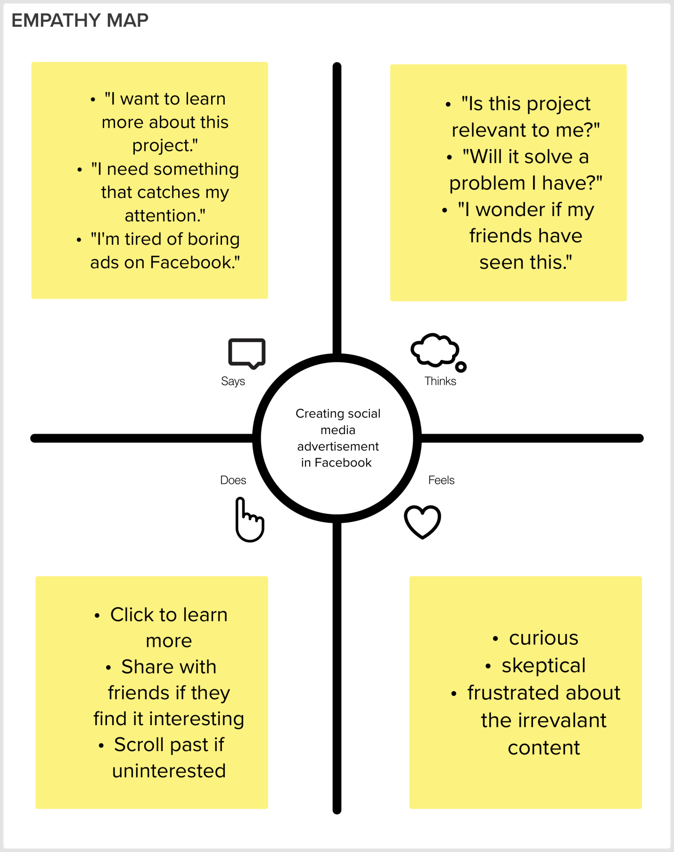

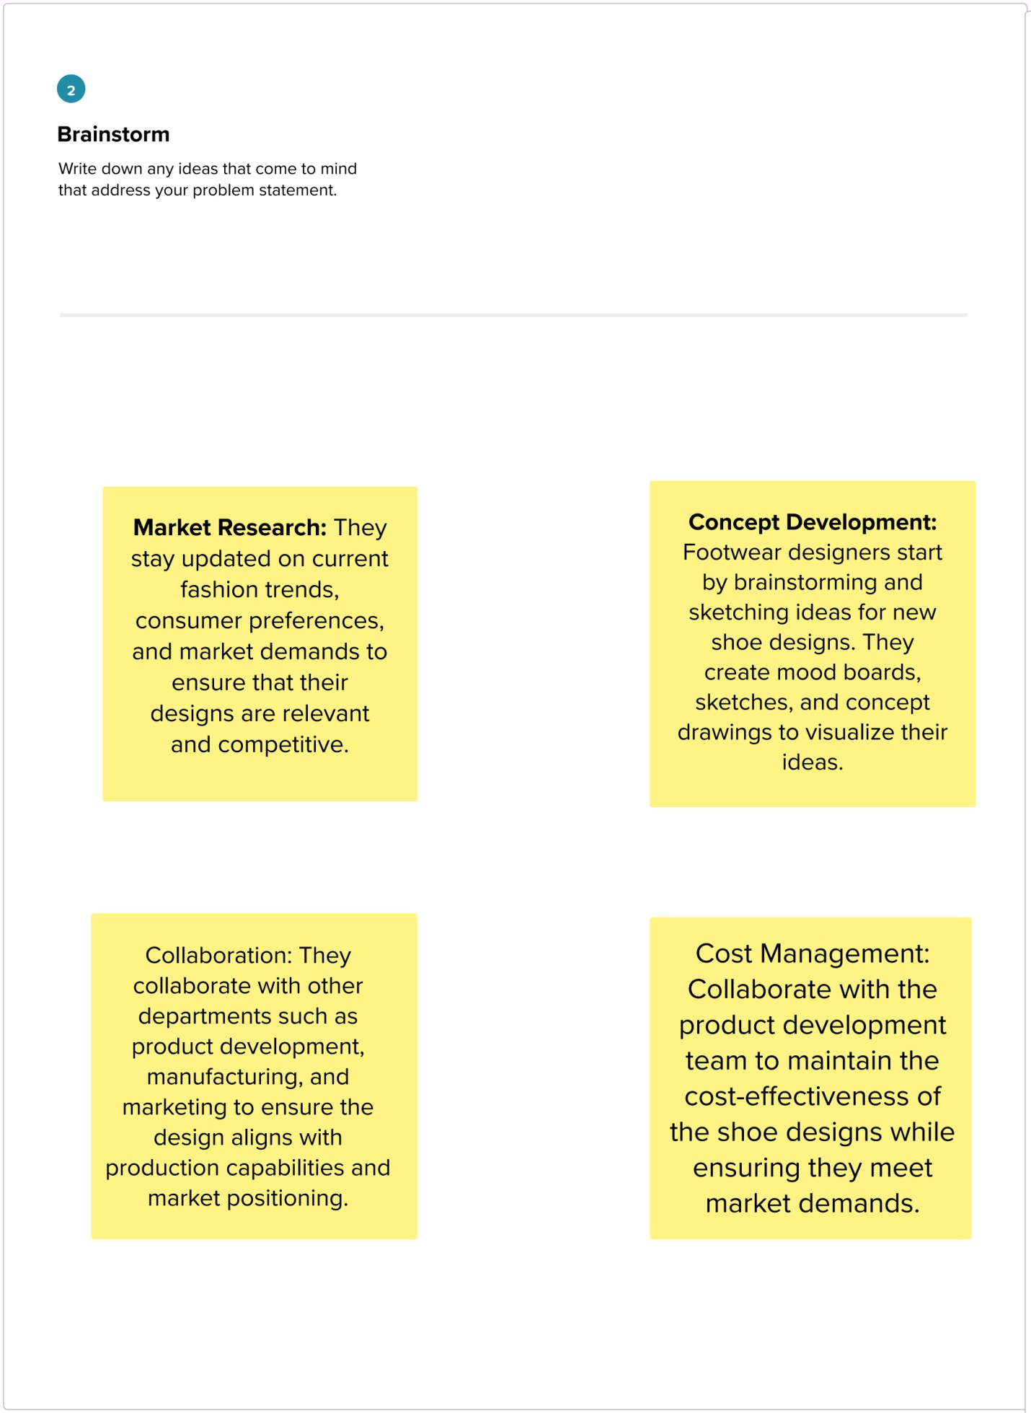

**CONCLUSION:**

In summary, Canva proves to be an invaluable resource for crafting social media advertisements on Facebook. Its user-friendly interface, versatile templates, and customization options empower users to create visually appealing and engaging ads. Leveraging Canva's capabilities allows advertisers to effectively reach their target audience, boost brand recognition, and drive meaningful engagement and conversions on the Facebook platform.

**VIDEO DEMONSTRATION LINK:** <https://drive.google.com/file/d/1dw7UnM36hEtdDnNx1GFfh_O3pHQ1Gnu_/view?usp=drive_link>

**PROJECT LINK:** <https://www.facebook.com/profile.php?id=100069268976825&mibextid=ZbWKwL>

**GITHUB LINK:**